REQUEST FOR THE SUBMISSION OF OFFERS FOR THE LEASE OF GREEN HILLS FIELD STATION, PORTLAND

ASSETS DEPARTMENT
3/8/2021

RFOFL# G.H.F.S. Proposal #001
This document is intended to guide interested parties concerning this opportunity and indicates the basis upon which proposals will be accepted and evaluated to conclude a selection.

PROPOSALS
Due on: October 29, 2021
and will be accepted until 10:00 a.m.

TABLE OF CONTENTS

1. GENERAL 3
2. APPLICATION DOCUMENT 6
3. PREPARATION OF APPLICATIONS 7
4. SUBMISSION OF OFFERS/APPLICATIONS 8
5. APPLICATION OPENING AND EVALUATION 10
6. NOTIFICATION OF BID AWARD 14
Appendix 1: APPLICATION TO LEASE 16
APPENDIX 2 - SITE LOCATION: IMAGES 17
APPENDIX 3–FLOOR PLAN 19

GENERAL
********************************
  - PROPRIETOR AND MISSION
The Institute of Jamaica (IOJ), an Agency of the Ministry of Culture, Gender, Entertainment and Sport was established in 1879, "for the Encouragement of Literature, Science and Art ". It was designed to help Government in the promotion and preservation of culture in the island and is therefore perceived as Jamaica's most significant cultural, artistic and scientific organization.

The IOJ has been the proprietor of the Green Hills property since its acquisition in 1964. The property is managed by the Natural History Museum of Jamaica (NHMJ), a division of IOJ with a mandate to:
- Encourage the study and dissemination of scientific knowledge of Jamaican flora and fauna.
- Promote the conservation of the Jamaican natural environment.
- Maintain collections of Jamaican flora, fauna and reference books
The NHMJ possesses a species list of some of the flora and fauna of the Green Hills property and has been encouraging field research on the various plants and animals that are habitants of the site. By NHMJ collaborating with the regional NGO, Birds Caribbean, Green Hills Field Station has been featured on their Caribbean Birding Trail as a birdwatching site. For further details visit https://www.caribbeanbirdingtrail.org/sites/jamaica/green-hills-field-station/.

  - INVITATION TO APPLICANTS
The Institute of Jamaica (hereinafter called “IOJ”) requests the submission of OFFERS for the lease of “Green Hills Field Station” in its current condition.

The property is uniquely nestled on 3.782 hectares of lush green land. It is not located within the boundaries of the Blue and John Crow Mountains National Park but it is found within the community buffer zone of the park. The Station houses a wooden structure consisting of a small kitchenette , six (6) bedrooms, three (3) en suite bathrooms, and one bathroom stall with two (2)toilets and two (2) showers.

It is located approximately 1.5 kilometres east of the Holywell National Recreational Park. The site is irregular in shape, below road level, undulating with gently to deeply sloping lands and with natural gullies. Green Hills forms part of the Blue Mountain range surrounded by Wallenford to the north, Mount Horeb and Newcastle to the South and Holywell to the West. It is situated approximately 4.5kilometres north of Jamaica Defence Force Training site at Newcastle.

The site is protected by the Natural Resources Conservation Authority Act and other legislations administered by the National Environment and Planning Agency would be applicable including among others, the Wild Life Protection Act, Watershed Protection Action Act and the Town and Country Planning Act and associated regulations.

Interested persons/companies MUST acquire a valid application form from the IOJ during the prescribed period of the Request for the Submission of Offers.

  - ELIGIBILITY/MANDATORY REQUIREMENTS
Applicants who will be considered eligible to participate MUST submit a duly signed and completed Application Form.
Further:
- Companies MUST submit a valid/current copy of its Certificate of Incorporation issued by the Office of the Registrar of Companies, Jamaica AND a copy of a valid Tax Compliance Letter (TCL) or Tax Compliance Certificate (TCC)

Offers submitted by a company without a valid/current copy of its Certificate of Incorporation issued by the Office of the Registrar of Companies, Jamaica and a copy of a valid Tax Compliance Letter (TCL) or Tax Compliance Certificate (TCC) will be deemed non-responsive, and therefore will be rejected.

- Individuals MUST submit a copy of their Taxpayer Registration Number (TRN) Card, Letter or Slip AND a copy of a current/valid Government of Jamaica-issued photo identification, specifically, a Driver’s Licence, Passport or National Identification Card.

Individuals submitting offers without a copy of their Taxpayer Registration Number (TRN) Card, Letter or Slip and using other forms of identification other than a Government of Jamaica issued photo identification, specifically, Driver’s Licence, Passport or National Identification Card will be deemed non-responsive and therefore rejected.

NB. The necessary supporting documents (TRN and Government issued photo identification) must be submitted for all persons registered/named on the application form. Applications submitted without the requisite supporting documents for all applicants will be deemed non-responsive and will be rejected. Failure to meet the prerequisites will render the bid invalid.

  - NOTIFICATION TO APPLICANTS
Offers MUST be made on the original prescribed application form included in the Appendices of this REQUEST FOR OFFERS DOCUMENT. Applications that are not submitted on the original prescribed form will be considered void/non-responsive and will be rejected

  - COST OF APPLYING
The applicant/company shall bear all costs associated with the preparation and submission of his/her o application.

  - SITE VISIT
Prospective lessees are strongly encouraged to attend undertake a reconnaissance. Interested parties are to make appointments for site visit by contacting the Assets Manager, Mr. Donovan Gordon at 876-922-0620-6 ext. 310 or email dgordon@instituteofjamaica.org.jm. The proposed site visit date is Wednesday, August 11, 2021 at 11:00 am. Kindly confirm your attendance on or before Monday, August 9, 2021 at 1:00 pm via email. IOJ has provided a sketch of the building (Appendix 2) for information purposes only. The dimensions are not meant to be used as working drawings. The IOJ assumes no responsibility for accuracy of the dimensions given neither on the sketch nor on the actual on-site conditions.

NB. The costs of visiting the site shall be at the applicant’s expense and risks. Applicants are advised to undertake inspections within a reasonable time as no extension of the submission deadline will be granted due to a failure to properly inspect the premises.

The prospective applicant will release and indemnify the IOJ and its personnel or agents from any and against all liability in respect of, and will be responsible for personal injury (whether fatal or otherwise), loss of or damage to property and any other loss, damage, costs and expenses however caused during the inspection, which but for the exercise would not have arisen.

APPLICATION DOCUMENT
********************************

  - CLARIFICATION OF INFORMATION PACKAGE BY APPLICANTS
  - Applicants may request clarification of the information relating to the property or the submission of an application by fax or email only, addressed as follows:

Assets Manager
Mr. Donovan Gordon
Fax No.: at 876-922-1147
Email address : dgordon@instituteofjamaica.org.jm
and copied to
dmullings@instituteofjamaica.org.jm

Re: Application to Lease Green Hills Field Station owned by the Institute of Jamaica.

  - The IOJ will also host a clarification meeting for ALL interested applicants are invited.

A virtual clarification meeting
Platform: google meeting
Date: September 3, 2021 Time: 10:00 a.m.
ID: meet.google.com/ppj-jvme-pdj
Join by phone
(US) +1 786-540-4148‬ PIN: 938 580 800‬#‬‬‬‬‬‬

  - AMENDMENT OF INFORMATION PACKAGE
At any time prior to the deadline for the submission of applications the IOJ may for any reason whether on its own initiative, or as a result of a request for clarification by a prospective applicant, modify the Information package by issuing an addendum, amendment or revision.

In order to afford prospective applicants reasonable time in which to take the amendment into account in preparing their applications, the IOJ may, at its discretion, extend the deadline for submission of applications.

PREPARATION OF APPLICATIONS
********************************

  - LANGUAGE
All correspondence and documents relating to the application shall be in English.

  - VALIDITY OF OFFER
Offers shall remain valid for the period of 120 days after the deadline of submission of offers. In exceptional circumstances, the Institute of Jamaica (IOJ) may request that the applicants extend the period of validity for a specified additional period. The request and the applicants’ responses shall be made in writing. An applicant agreeing to the request will not be required or permitted to otherwise modify the Offer. An applicant who does not agree to extend the period of validity would be discontinued in the tender process.

  - DESCRIPTION OF THE PREMISES

    - BUILDING CONDITION AND LESSEE CONSTRUCTION RESTRICTIONS
The Green Hills Field Station is an old building that requires some infrastructural improvements. This includes but is not limited to:
- The walkway from entrance to the property may need to be retrofitted to include hand rails leading to house or the walkway could be converted to give a staircase effect.
- Renovation of the room in the Basement
- Minor repairs to plumbing system
- Replacement of floor boards and windows
- Repair roof, treat and paint ceiling.
- Replace the back door to the passage and kitchen door.
- Construct functional Bathroom and Kitchen for Caretaker in Basement

  - LIMITATIONS ON USE

The property can be leased for uses listed but not limited to these once the conservation of the environment/ecosystem is considered.

- The divestment of this property is for the preservation of natural resources and the environment.
- The promotion of economic and infrastructural development
- The promotion of social capital formation

3.3.1.4. The building for the Green Hills Field Station may be modified following approval from the IOJ. Proposers should read the lease in its entirety before submitting proposals. Activities contrary to the mandate and values of the Agency will not be considered. This includes but not limited; to farming that requires the use of fertilizers or any other chemicals that will affect the natural ecosystem or any form of burning.

SUBMISSION OF OFFERS/APPLICATIONS
********************************

Proposals that are not responsive to this RFOFL will not be considered.

    - Bidders MUST complete the application form. The requested information must be provided in full in accordance with the instructions within this RFOL an applicant fails to provide any of the requested information, the proposal may be considered to be non-responsive.
    - An original and one (1 copy of the proposal are required.
    - The name, postal address, telephone number, and email address of the individual authorized to negotiate on behalf of the proposer (power of attorney) must be furnished.
    - The IOJ may award a lease based on initial proposals received. Accordingly, each proposal should contain the most favourable terms to the IOJ, from a technical and monetary standpoint, that the applicant can submit.
    - This RFOL includes the criteria to be used by the IOJ to evaluate the proposals. Applicants should ensure that they address the criteria provided. The responses to the criteria are what will be evaluated in order to select the best proposal. The questions provided beneath the criteria should be individually addressed. However, they are not intended to be the only information one could or should provide in addressing those criteria.
    - To be considered responsive, the proposal must provide all pertinent information regarding the criteria, and the questions identified below the criteria, and to the other requirements of this RFOL.

  - DEADLINE FOR SUBMISSION OF APPLICATIONS
Offers shall be submitted via a completed and signed Application and returned along with:

- Companies must submit
  - a copy of its Certificate of Registration issued by the Office of the Registrar of Companies
  - a copy of a valid Tax Compliance Letter (TCL) or Tax Compliance Certificate (TCC)
  - A copy of bidder’s business plan with audited financial statements if it is an existing business; or
  - Show the estimates in the form of the annual pro forma income statements.

- Individuals must submit
  - a copy of their Taxpayer Registration Number (TRN) Card,
  - Letter or Slip AND a copy of a current/valid Government issued photo identification, specifically, a Driver’s Licence, Passport or National Identification Card. (Applicants submitting offers using other forms of identification other than a Government of Jamaica issued photo identification will be deemed non-responsive and therefore rejected)
  - A copy of bidder’s business plan with audited financial statements if it is an existing business; or
  - Show the estimates in the form of the annual pro forma income statements.

Offers MUST be deposited in the tender box located at the Institute of Jamaica, 10-16 East Street, Kingston before 10:00 a.m. Friday October 29, 2021.

  - LATE SUBMISSION OF OFFERS/APPLICATIONS
Any offer/application received after the prescribed deadline for submission will NOT be considered and will BE RETURNED UNOPENED TO APPLICANT.

APPLICATION OPENING AND EVALUATION
********************************

  - OFFER/APPLICATION OPENING
The members of the procurement team for this initiative will open the Offers/Applications on Friday, October 29, 2021 at 10:15 a.m. in the Council Chamber at the Institute of Jamaica. All applicants or their representatives are invited to attend.

The applicant’s name(s) and such other details will be announced at the Opening. No application shall be rejected at the Opening.

  - APPLICATION WITHOUT KNOWLEDGE OF OTHERS
Applications shall be submitted without any connection of figures or agreement with any other person or persons submitting an application for the same property and shall be in all aspects fair and without collusion or fraud. All applications shall be treated with strict confidence.

  - CLARIFICATION OF OFFERS BY THE INSTITUTE OF JAMAICA
The IOJ reserves the right to request, during the evaluation process, any additional information from the applicant as may be required to clarify any issue relating to the application. No adjustments of any kind will be allowed once the application has been submitted.

  - EVALUATION CRITERIA
All applications shall be assessed based on the following criteria.

    - Selection Criteria
Evaluation of proposals will be done by the Institute of Jamaica and will result in the selection of the proposal which most convincingly demonstrates

      - THE COMPATABILITY OF THE PROPOSAL WITH THE ENVIRONMENTAL VALUE OF THE PROPERTY AND ITS SURROUNDINGS

Submit a detailed Business plan, specifying the proposed use of the property, related experience to this type of business, including specific information on proposed merchandise, services, or related activities. The proposal should be consistent with the lease terms.

The Business Plan should provide as much detail regarding the staffing, competencies, business and proposed use of the building as possible. Be sure to include the proposed schedule of operation (including months, days, and hours).

The IOJ will evaluate the compatibility of the proposal’s intended use of the leased property with respect to preservation, and protection of the site. This will include, but not be limited to, how well the operating plan minimizes negative environmental factors such as, noise, disruption to the natural ecosystem and changes to the physical infrastructure.

Some proposed uses of the property include but is not limited to :
- Guest House/Bed and Breakfast
- Research facility
- Base for an Eco Trail with display for gift shop and coffee shop
- Garden and Nature Trails
- Retreat Facility
- Counselling Centre
- Spa

      - THE FINANCIAL CAPABILITY TO MANAGE THE PROPERTY
The applicant must be able to demonstrate their financial ability to meet the lease obligations.
- Provide estimates of the revenues and expenses for the business that will operate in the building for the first five years of operation- A Business Plan
- Provide audited financial statements if it is an existing business; or
- Show the estimates in the form of the annual pro forma income statements.
- If applicable, include debt payments for the initial business investment.
- Explain the assumptions on which the projections are based to a degree sufficient for reviewers to judge the validity of the estimates.
More detail is preferred over less.

      - THE EXPERIENCE OF THE PROPOSER DEMONSTRATING THE MANAGERIAL CAPABILITY TO CARRY OUT THE TERMS OF THE LEASE.
The Applicant must be able to explain aptly how the site will be maintained. A clear maintenance programme must be shown which is inclusive of
- Maintenance schedule for the building and grounds
    - Solid waste disposal
    - Vector and disease control strategies
    - Frequency and Type of Water Quality testing
    - Washroom and waste water treatment facilities
    - Pruning of trees and gardening

- Security and Grounds
- Level and type of security to be provided especially if the property is being leased without the caretaker.
Also describe your experience in managing the type of operation proposed for the lease, or similar operations and outcomes. Provide detailed resumes for all current and proposed owners and key management personnel including the proposed on-site manager. Identify the specific role the individual is to play and the person's ability to play that role. State whether you have ever defaulted from or been terminated from a management contract or lease, or been forbidden from contracting.

Any other information required which the applicant considers necessary to the development.

      - THE ABILITY AND COMMITMENT OF THE APPLICANT TO CONDUCT ITS ACTIVITIES AT GREEN HILLS IN AN ENVIRONMENTALLY ENHANCING MANNER THROUGH, AMONG OTHER PROGRAMS AND ACTIONS, ENERGY CONSERVATION, WASTE REDUCTION, AND RECYCLING.
The Applicant must be able describe and demonstrate how:
- they would apply environmental conservation or enhancement activities.
- the proposed operation will integrate the use of the physical environment and
the project will integrate/ engage the surrounding communities.

Institute of Jamaica reserves the right to seek additional information and or expertise in order to adequately evaluate any proposal.

    - LEASE AMOUNT BEING PROPOSED

      - Evaluation Criteria
The minimum score to qualify to be shortlisted is 70. The total score will be as a result of summing all points and the entity or person with the highest score will be recommended to the Board. IOJ reserves the right to indicate to the second highest bidder that they will be considered in the event that the successful bidder fails to contract with IOJ.

All proposals received will be evaluated based on the following schedule/criteria.

RUBRIC FOR EVALUATION OF PROPOSALS
No. | Criterion | Description | Score |  | Evaluator  Score
1 | THE COMPATABILITY OF THE PROPOSAL WITH THE ENVIRONMENTAL VALUE OF THE PROPERTY AND ITS SURROUNDINGS | - Alignment with the Institute of Jamaica’s mandate to maintain, preserve and protect the natural flora and fauna of the site  - How many years have you worked in the field of heritage tourism, culture, science or history  1-5yrs (5 points) ; 6-9 (8 points); 10 and over 10 yrs (10 points) | 10 | 30
 |  | - The Development Plan includes the protection and preservation of the site  - Liquid and Solid Waste plan (5 points)  - Renovation of site (10 points )  - Minimal environmental disruption by the construction/ repair of new/old infrastructure on the property for example no major earthwork to cause damage to the flora and fauna (5) | 20
2 | THE FINANCIAL CAPABILITY TO MANAGE THE PROPERTY | - Evidence of ability to finance such as bank statement, etc | 5 | 10
 |  | - Feasibility of the development plan to be implemented – Business Plan | 5
3 | THE EXPERIENCE OF THE APPLICANT DEMONSTRATING THE MANAGERIAL CAPABILITY TO CARRY OUT THE TERMS OF THE LEASE. | - Work plan inclusive of a maintenance schedule for the proposed period of the Lease | 10 | 25
 |  | Related experience in this type of business  - 6 months to 3 years 4 points  - 4- 6 years 7 points  - Over 7 years’ experience 10 points | 10
 |  | - Competency of the management team  (Training in Management/Educational Qualification) | 5
4 | THE ABILITY AND COMMITMENT OF THE APPLICANT TO CONDUCT ITS ACTIVITIES AT GREEN HILLS IN AN ENVIRONMENTALLY ENHANCING MANNER THROUGH, AMONG OTHER PROGRAMS AND ACTIONS, ENERGY CONSERVATION, WASTE REDUCTION, AND RECYCLING. | - Marketing strategy | 10 | 25
 |  | - Benefit to IOJ/community and the environment  - Significant benefit 15 points  - Average benefit 10 points  - Minimal benefit 5 points | 15
5 | LEASE AMOUNT BEING PROPOSED | Amount must not be below market level | 10 | 10
Overall Maximum Score |  |  | 100

  - AWARD CRITERIA
Only the applicant who is substantially responsive and with the highest point will be awarded the contract to lease the property.

    - REQUIREMENTS PERTAINING TO THE LEASE
- The Lessee is responsible for all taxes or fees arising from occupancy or business activity.
- All utility expenses must be paid directly by the Lessee (i.e. water, sewage, electricity, phone, Internet, etc.)

The Use of property by IOJ

- The IOJ reserves the right to access the premises for field research, or any other uses that the Executive Director determines may be in the best interest of the NHMJ.
- The IOJ reserves the right to conduct inspection of the site to ensure that the lease terms are being maintained. At least two days’ notice will be given for such visits..

- The IOJ retains authority over the preservation of the grounds and total approval authority over their use of the facility.
- The lease of property will not exceed 15 years.

NOTIFICATION OF BID AWARD
********************************

  - NOTIFICATION TO SUCESSFUL APPLICANT
Notification of the successful applicant will be done after receipt of approval from the Procurement Committee. The IOJ will notify the successful applicant(s) in writing.

The IOJ shall, in the case of a “tie-bid situation” where the higher offer meets or exceed the reserved price, notify and invite the relevant bidders to submit a further offer which is above their existing bid.

  - IOJ’s RIGHT TO ACCEPT ANY BID/OFFER AND TO REJECT ANY OR ALL BID/OFFERS

- The IOJ shall not be bound to award the property to the Applicant with the highest offer or to award the Property at all, having the power to consider all the Bids received not acceptable and therefore declaring the Application cancelled.
- The IOJ shall have the right to delay the award of the property within the limits of the validity of the Application.
- The IOJ shall have the right to waive any information or requirement in the Bids received, and to accept any Bids considered advantageous to them.
- The IOJ shall not be bound to regard any claim regarding either the procedure or the result of the Application.

The IOJ reserves the right to accept or reject any or all applications or to withdraw the advertisement, at any time prior to the closing date of such advertisement without incurring any liability.

  - CODE OF CONDUCT
Government of Jamaica Public Sector Procurement Procedures shall be afforded the highest practicable degrees of objectivity. In circumstances of conflicting interests, e.g. parties involved in the procurement process and who have connection(s) with participating applicant(s), the GOJ’s party must so declare at the onset of the procurement process or whenever the party becomes aware of the conflict, whichever is sooner, and shall immediately disqualify himself/herself from participating in the particular procurement process.

APPENDIX 2 - SITE LOCATION: IMAGES
Figure 1: Walkway to the Green Hills Field Station
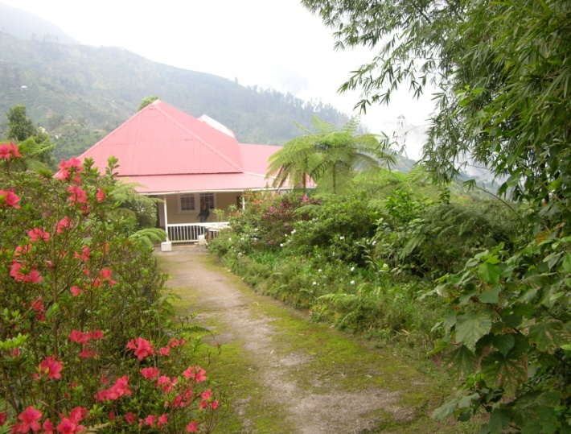

Figure 2: The Patio at Green Hills

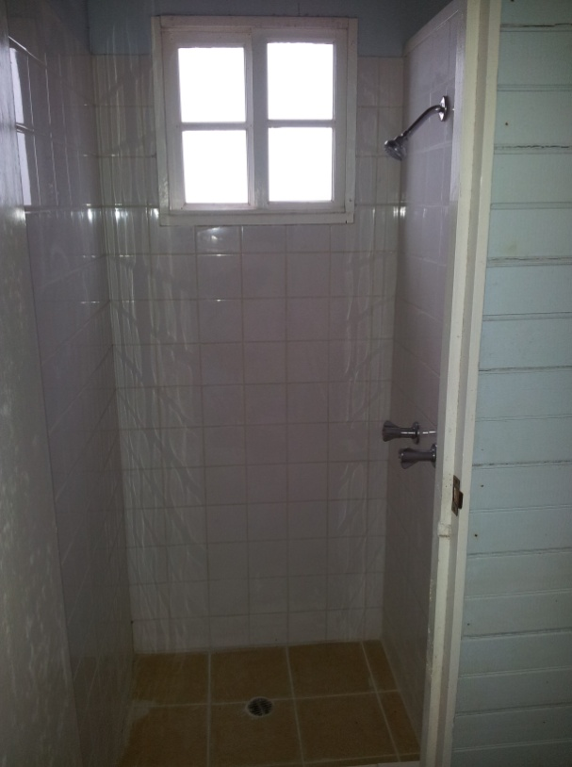
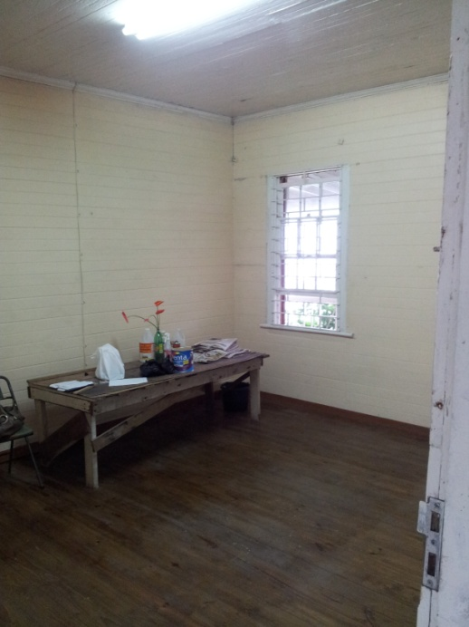
Figure 4: Bathroom Stalls
Figure 3: The Foyer at the Station

Figure 3: Kitchen Space at the Station

APPENDIX 3–Sketch of the Property

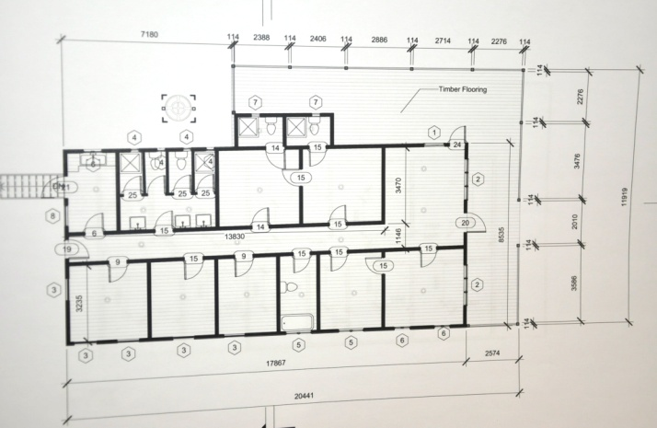

All such requests shall be submitted in writing not less than five (5) days before the closing date of application. The Institute of Jamaica (IOJ) shall respond to these requests in writing by means of a letter which will be sent by electronic mail not less than three (3) days prior to the time set for the return of applications. No telephone queries will be accepted.

