REQUEST FOR THE SUBMISSION OF OFFERS FOR THE LEASE OF ALTAMONT DACOSTA INSTITUTE AND ADJOINING PROPERTIES

ASSETS DEPARTMENT
3/8/2021

This document is intended to guide interested parties concerning this opportunity and indicates the basis upon which proposals will be accepted and evaluated to conclude a selection.

Request for the Submission of Offers: April 29, 2021
Submission date: Thursday, October 28, 2021 at 10:00 a.m.

TABLE OF CONTENTS

1. GENERAL 3
2. APPLICATION DOCUMENT 6
3. PREPARATION OF APPLICATIONS 7
4. SUBMISSION OF OFFERS/APPLICATIONS 8
5. APPLICATION OPENING AND EVALUATION 10
6. NOTIFICATION OF BID AWARD 14
Appendix 1: APPLICATION TO LEASE 16
APPENDIX 2: 1 Central Avenue, Kingston Gardens, KINGSTON 17
APPENDIX 3 – Images: 3 Central Administration, Kingston Gardens 21
APPENDIX 4 – Images: 11/2 North Street, Kingston Gardens 23

GENERAL
********************************
  - PROPRIETOR AND MISSION
The Institute of Jamaica (hereinafter called “IOJ”), an Agency of the Ministry of Culture, Gender, Entertainment and Sport was established in 1879 by Sir Anthony Musgrave, then Governor of Jamaica, "for the Encouragement of Literature, Science and Art", and as such was designed to help Government in the promotion and preservation of culture in the island. It is Jamaica's most significant cultural, artistic and scientific organization.

The IOJ has been the proprietor of the Altamont DaCosta Institute since its acquisition in 1936. It was bequeath to the IOJ by Mr. Altamont Earnest Dacosta for the use as a library, museum or Institute.

  - INVITATION TO APPLICANTS
The IOJ requests the submission of OFFERS for the total lease of “Altamont DaCosta Institute” and adjoining properties for commercial purposes.

This Request for Offer for lease (RFOFL) provides the opportunity for interested individuals or entities to submit proposals to the Institute of Jamaica (IOJ) to lease the Altamont Dacosta Institute and its adjoining properties located at, Kingston Gardens . Applicants must be reputable entities: cooperatives, companies, etc.; with the requisite tax compliant registration (TCC) and with a track record of similar undertakings.

The “Altamont DaCosta Institute” is a single residential storey of Georgian style and is of gross external area of approximately 223.96 square metres (extended repairs required), while the related properties 1 ½ North Street and 3 Central Avenue have no structures on site (see table below). The properties are located approximately 0.5km South-east of the National Heroes Circle and is part of the Kingston Gardens community.

Table 1: Properties for Lease
Properties | Address | Size
Altamont DaCosta Institute | 1 Central avenue | 11,754.57 sq.feet /1,092 sq. meters
Adjoining vacant lot | 3 Central Avenue | 12,500 sq.feet/1,161.25 sq. meters
Vacant lot | 1 ½ North Street | 19,747 square feet/ 1,834.49 sq. meters

Interested persons/companies MUST acquire a valid Application form (Appendix 1) from the IOJ during the prescribed period of the Request for the Submission of Offers.

  - ELIGIBILITY/MANDATORY REQUIREMENTS
Applicants who will be considered eligible to participate MUST submit a duly signed and completed Application Form.
Further:
- Companies MUST submit a valid/current copy of its Certificate of Incorporation issued by the Office of the Registrar of Companies, Jamaica AND a copy of a valid Tax Compliance Letter (TCL) or Tax Compliance Certificate (TCC)

Offers submitted by a company without a valid/current copy of its Certificate of Incorporation issued by the Office of the Registrar of Companies, Jamaica and a copy of a valid Tax Compliance Letter (TCL) or Tax Compliance Certificate (TCC) will be deemed non-responsive, and therefore will be rejected.

- Individuals MUST submit a copy of their Taxpayer Registration Number (TRN) Card, Letter or Slip AND a copy of a current/valid Government of Jamaica-issued photo identification, specifically, a Driver’s Licence, Passport or National Identification Card.

Individuals submitting offers without a copy of their Taxpayer Registration Number (TRN) Card, Letter or Slip and using other forms of identification other than a Government of Jamaica issued photo identification, specifically, Driver’s Licence, Passport or National Identification Card will be deemed non-responsive and therefore rejected.

NB. The necessary supporting documents (TRN and Government issued photo identification) must be submitted for all persons registered/named on the application form. Applications submitted without the requisite supporting documents for all applicants will be deemed non-responsive and will be rejected. Failure to meet the prerequisites will render the bid invalid.

  - NOTIFICATION TO APPLICANTS
Offers MUST be made on the original prescribed application form included in the Appendices of this REQUEST FOR OFFERS DOCUMENT. Applications that are not submitted on the original prescribed form will be considered void/non-responsive and will be rejected.

  - COST OF APPLYING
The applicant/company shall bear all costs associated with the preparation and submission of his/her or the company’s application.

  - SITE VISIT
Prospective lessees are strongly encouraged to attend undertake a reconnaissance. Interested parties are to make appointments for site visit by contacting the Assets Manager, Mr. Donovan Gordon via email at dgordon@instituteofjamaica.org.jm. The proposed site visit date is Tuesday, August 10, 2021 at 11:00 am. Kindly confirm your attendance on or before Thursday, August 5, 2021 at 2:00 p.m. via email. IOJ has provided images of the various locations (Appendix 2 to 4) for information purposes only.

NB. The costs of visiting the site shall be at the applicant’s expense and risks. Applicants are advised to undertake inspections within a reasonable time as no extension of the submission deadline will be granted due to a failure to properly inspect the premises.

The prospective applicant will release and indemnify the IOJ and its personnel or agents from any and against all liability in respect of, and will be responsible for personal injury (whether fatal or otherwise), loss of or damage to property and any other loss, damage, costs and expenses however caused during the inspection, which but for the exercise would not have arisen.

APPLICATION DOCUMENT
********************************

  - CLARIFICATION OF INFORMATION
Applicants may request clarification of the information relating to the property or the submission of an application by fax or email only, addressed as follows by September 1, 2021:

Mr. Donovan Gordon
Assets Manager
Fax No.: at 876-922-1147
Email address : dgordon@instituteofjamaica.org.jm
and copied to
dmullings@instituteofjamaica.org.jm

Re: Application to Lease of “Altamont DaCosta Institute” owned by the Institute of Jamaica

  - AMENDMENT OF INFORMATION
At any time prior to the deadline for the submission of applications the IOJ may for any reason whether on its own initiative, or as a result of a request for clarification by a prospective applicant, modify the Information Package by issuing an addendum, amendment or revision.

At any time prior to the deadline for the submission of applications the IOJ may for any reason whether on its own initiative, or as a result of a request for clarification by a prospective applicant, modify the Information package by issuing an addendum, amendment or revision.

In order to afford prospective applicants reasonable time in which to take the amendment into account in preparing their applications, the IOJ may, at its discretion, extend the deadline for submission of applications.

PREPARATION OF APPLICATIONS
********************************

  - LANGUAGE
All correspondence and documents relating to the application shall be in English.

  - VALIDITY OF OFFER
Offers shall remain valid for the period of 120 days after the deadline of submission of offers. In exceptional circumstances, the Institute of Jamaica (IOJ) may request that the applicants extend the period of validity for a specified additional period. The request and the applicants’ responses shall be made in writing. An applicant agreeing to the request will not be required or permitted to otherwise modify the Offer. An applicant who does not agree to extend the period of validity would be discontinued in the tender process.

  - DESCRIPTION OF THE PREMISES
    - BUILDING CONDITIONS AND LESSEE CONSTRUCTION RESTRICTIONS

Property 1: The “Altamont DaCosta Institute” is located on the western side of the Central Avenue and east of Conrad Lane and is situated approximately 60 meters north of the Central Avenue and North Street intersection. The building is rectangular in shape, evenly graded, above the road level and appears to be free draining. The site supports three (3) buildings, two (2) of which are at an advance state of disrepair. The other main building is a single storey residential type structure of Georgian design containing a gross external area 2,410.78 square feet (223.96 square meters).

- Utilities and Services:
The location of the property is served by modern urban facilities including piped water supply, electricity, street lighting, police and fire protection, postal delivery, garbage collection, telephone and cable services, paved roadways and public transportation.

- Special Conditions:
This 75 years old building is in need of decorative repairs and some amount of renovation works to made it suitable for occupation.

- Limitations on Use
The “Altamont DaCosta Institute” is on the list of heritage site declared by the Jamaica National Heritage Trust. Leasees must seek the approval of IOJ before any changes can be made to the structure and/ or painting of the building.

Property 2: 3 Central Avenue
The site is rectangular is shape, above road level, evenly graded and appears free draining. Site coverage comprises tree shrubs. The boundaries are partially secured. There is a derelict building on site.

Property 3: 1 1/ 2 North Street is an empty lot
This is a corner lot which is above road level and is irregular in shape. Site coverage includes bare earth and grassed area.

SUBMISSION OF OFFERS/APPLICATIONS
********************************

Proposals for such uses will not be responsive to this RFOFL and will not be considered.

    - Bidders MUST complete the application form (Appendix 1). The requested information must be provided in full in accordance with the instructions within this RFOL. If an applicant fails to provide any of the requested information, the proposal may be considered to be non-responsive.
    - An original and two (2) equal copies of the proposal are required.
    - The name, postal address, telephone number, and email address of the individual authorized to negotiate on behalf of the proposer (power of attorney) must be furnished.
    - The IOJ may award a lease based on initial proposals received. Accordingly, each proposal should contain the most favourable terms to the IOJ, from a technical and monetary standpoint, that the applicant can submit.
    - This RFOFL includes, IN BOLD CAPITAL LETTERS, the criteria to be used by the IOJ to evaluate the proposals. Applicants should ensure that they address the criteria provided. The responses to the criteria are what will be evaluated in order to select the best proposal. The questions provided beneath the criteria should be individually addressed. However, they are not intended to be the only information one could or should provide in addressing those criteria.
    - To be considered responsive, the proposal must provide all pertinent information regarding the criteria, and the questions identified below the criteria, and to the other requirements of this RFOFL.

  - DEADLINE FOR SUBMISSION OF APPLICATIONS
Offers shall be submitted via a completed and signed Application and returned along with:

- Companies must submit
  - a copy of its Certificate of Registration issued by the Office of the Registrar of Companies
  - a copy of a valid Tax Compliance Letter (TCL) or Tax Compliance Certificate (TCC)
  - A copy of bidder’s business plan with audited financial statements if it is an existing business; or
  - Show the estimates in the form of the annual pro forma income statements.

- Individuals must submit
  - a copy of their Taxpayer Registration Number (TRN) Card,
  - Letter or Slip AND a copy of a current/valid Government issued photo identification, specifically, a Driver’s Licence, Passport or National Identification Card. (Applicants submitting offers using other forms of identification other than a Government of Jamaica issued photo identification will be deemed non-responsive and therefore rejected)
  - A copy of bidder’s business plan with audited financial statements if it is an existing business; or
  - Show the estimates in the form of the annual pro forma income statements.

Offers MUST be deposited in the tender box located at the Institute of Jamaica, 10-16 East Street, Kingston before 10:00 a.m. Thursday, October 28, 2021.

  - LATE SUBMISSION OF OFFERS/APPLICATIONS
Any offer/application received after the prescribed deadline for submission will NOT be considered and will BE RETURNED UNOPENED TO APPLICANT.

APPLICATION OPENING AND EVALUATION
********************************

  - OFFER/APPLICATION OPENING
The members of the IOJ team will open the Offers/Applications on Thursday, October 28, 2021 at 10:00 a.m. in the Council Chamber at the Institute of Jamaica. All applicants or their representatives are invited to attend. No application shall be rejected at the Opening.

  - APPLICATION WITHOUT KNOWLEDGE OF OTHERS
Applications shall be submitted without any connection of figures or agreement with any other person or persons submitting an application for the same property and shall be in all aspects fair and without collusion or fraud. All applications shall be treated with strict confidence.

  - CLARIFICATION OF OFFERS BY THE INSTITUTE OF JAMAICA
The IOJ reserves the right to request, during the evaluation process, any additional information from the applicant as may be required to clarify any issue relating to the application. No adjustments of any kind will be allowed once the application has been submitted.

  - EVALUATION CRITERIA
All applications shall be assessed based on the following criteria.

    - Selection Criteria
Evaluation of proposals will be done by the Institute of Jamaica and will result in the selection of the proposal which most convincingly demonstrates

      - SUBMISSION OF A BUSINESS PLAN

Applicants should submit a Business plan, specifying the proposed use of the property, related experience to this type of business, including specific information on proposed services, or related activities. It should also provide as much detail regarding the staffing, and competencies. The proposal should be consistent with terms for the use of the building.

The IOJ will evaluate the compatibility of the proposal’s intended use of the leased property with respect to preservation, and protection of the site.

      - THE FINANCIAL CAPABILITY TO MANAGE THE PROPERTY
The applicant must be able to demonstrate their financial ability to meet the lease obligations.
- Provide estimates of the revenues and expenses for the business that will operate in the building for the first five years of operation
- Provide audited financial statements if it is an existing business; or
- Show the estimates in the form of the annual pro forma income statements.
- If applicable, include debt payments for the initial business investment.

More detail is preferred over less.

      - THE EXPERIENCE OF THE PROPOSER DEMONSTRATING THE MANAGERIAL CAPABILITY.

The Applicant must be able to explain how the site will be maintained. A clear maintenance programme must be shown which is inclusive of:
- Maintenance schedule for the building and grounds
    - Solid waste disposal
    - Vector and disease control strategies
    - Clearing of the land, pruning of trees and gardening
- Security and Grounds
- Level and type of security to be provided
Also describe your experience managing the type of operation proposed for the lease, or similar operations and outcomes. Provide detailed resumes for all current and proposed owners and key management personnel including the proposed on-site manager. Identify the specific role the individual is to play and that person's ability to play that role. State whether you have ever defaulted from or been terminated from a management contract or lease, or been forbidden from contracting.

Any other information required which the applicant considers necessary to the development.

      - LEASE AMOUNT BEING PROPOSED

The Applicant must stipulate the amount they are prepared to pay for the lease per annum for the interested property/properties.

    - Evaluation Criteria
The minimum score to qualify to be shortlisted is 70.The total score will be as a result of summing all points and the entity or person with the highest score will be recommended to the Board. IOJ reserves the right to indicate to the second highest bidder that they will be considered in the event that the successful bidder fails to contract with IOJ.

All proposals received will be evaluated based on the following schedule/criteria.

RUBRIC FOR EVALUATION OF PROPOSALS
No. | Criterion | Description | Score |  | Evaluator  Score
1 | SUBMISSION OF A BUSINESS PLAN | - Applicants specify the use of the property (1 marks).  - Evidence of related experience to this type of business, including information on proposed services, or related activities. (4 marks).  - It should also provide as much detail regarding the staffing and competencies (5 marks). | 10 | 25
 |  | - The proposal should be consistent with terms for the use of the building. (15 marks). | 15
2 | THE FINANCIAL CAPABILITY TO MANAGE THE PROPERTY | - Evidence of ability to finance such as bank statement, etc | 5 | 10
 |  | - Provide estimates of the revenues and expenses for the business that will operate in the building for the first five years of operation | 5
3 | THE EXPERIENCE OF THE APPLICANT DEMONSTRATING THE MANAGERIAL CAPABILITY TO CARRY OUT THE TERMS OF THE LEASE. | - Work plan inclusive of a maintenance schedule for the proposed period of the Lease | 10 | 30
 |  | - Related experience in this type of business  - 6 months to 3 years 4 points  - 4- 6 years 7 points  - Over 7 years’ experience 10 points | 10
 |  | - Competency of the management team | 10
4 | LEASE AMOUNT BEING PROPOSED | - Amount must not be below market level | 10 | 10
Overall Maximum Score |  |  | 100

  - AWARD CRITERIA
Only the applicant who is substantially responsive and with the highest point will be awarded the contract to lease the property.

    - REQUIREMENTS PERTAINING TO THE LEASE
- The Lessee is responsible for all taxes or fees arising from occupancy or business activity.
- All utility expenses must be paid directly by the Lessee (i.e. water, sewage, electricity, phone, Internet, etc.)
- The IOJ is willing to negotiate its rights to use the grounds of the premises for field research, or any other uses that the Executive Director determines may be in the best interest of the NHMJ
- The IOJ retains authority over the preservation of the grounds and total approval authority over their use of the facility.
- The lease of property is for a period between 5-10 years.

NOTIFICATION OF BID AWARD
********************************

  - NOTIFICATION TO SUCESSFUL APPLICANT
Notification of the successful applicant will be done after receipt of approval from the Procurement Committee. The IOJ will notify the successful applicant(s) in writing.

The IOJ shall, in the case of a “tie-bid situation” where the higher offer meets or exceed the reserved price, notify and invite the relevant bidders to submit a further offer which is above their existing bid.

  - IOJ’s RIGHT TO ACCEPT ANY BID/OFFER AND TO REJECT ANY OR ALL BID/OFFERS

- The IOJ shall not be bound to award the property to the Applicant with the highest offer or to award the Property at all, having the power to consider all the Bids received not acceptable and therefore declaring the Application cancelled.
- The IOJ shall have the right to delay the award of the property within the limits of the validity of the Application.
- The IOJ shall have the rights to waive any information or requirement in the Bids received, and to accept any Bids considered advantageous to them.
- The IOJ shall not be bound to regard any claim regarding either the procedure or the result of the Application.

The IOJ reserves the right to accept or reject any or all applications or to withdraw the advertisement, at any time prior to the closing date of such advertisement without incurring any liability.

  - CODE OF CONDUCT
Government of Jamaica Public Sector Procurement Procedures shall be afforded the highest practicable degrees of objectivity. In circumstances of conflicting interests, e.g. parties involved in the procurement process and who have connection(s) with participating applicant(s), the GOJ’s party must so declare at the onset of the procurement process or whenever the party becomes aware of the conflict, whichever is sooner, and shall immediately disqualify himself/herself from participating in the particular procurement process.

APPENDIX 2: 1 Central Avenue, Kingston Gardens, KINGSTON

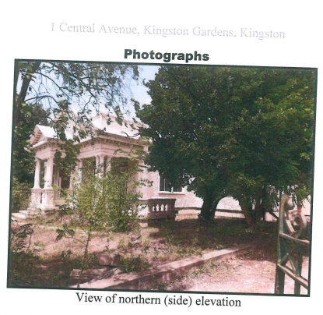

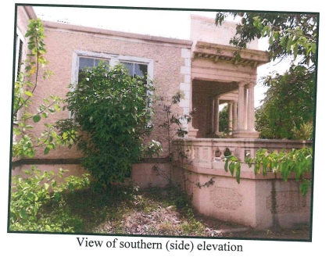

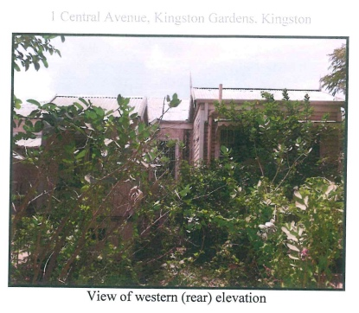

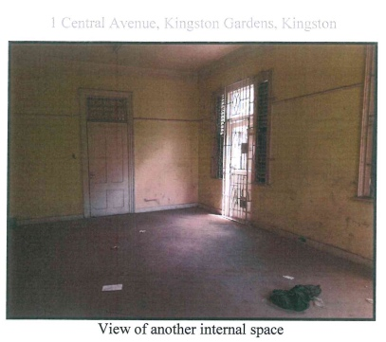

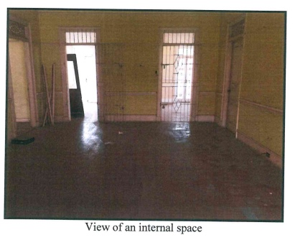

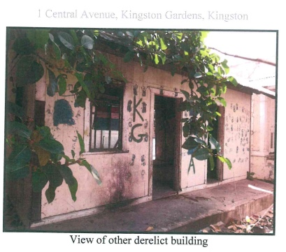

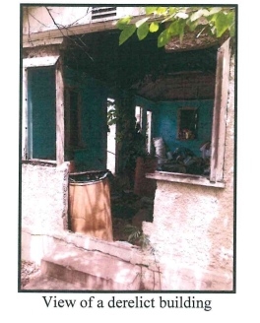

APPENDIX 3 – Images: 3 Central Administration, Kingston Gardens

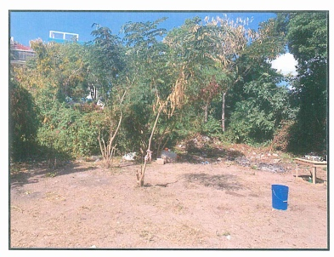

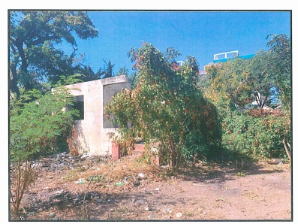

APPENDIX 3 – Images: 3 Central Administration, Kingston Gardens
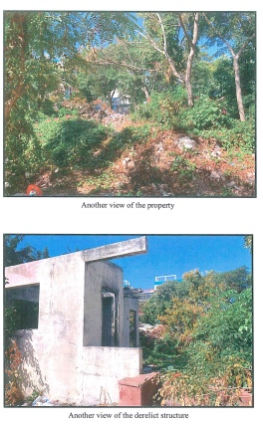

APPENDIX 4 – Images: 11/2 North Street, Kingston Gardens

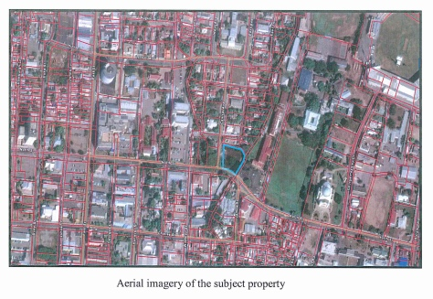

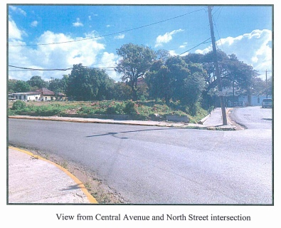

All such requests shall be submitted in writing not less than five (5) days before the closing date of application. The Institute of Jamaica (IOJ) shall respond to these requests in writing by means of a letter which will be sent by electronic mail not less than three (3) days prior to the time set for the return of applications. No telephone queries will be accepted.

